**NETWORKING TECHNOLOGIES- 2 HOURS**

**SECTION A- COMPULSORY**

**QUESTION 1**

Your company is appointed as consultant for a new Call Centre in Mauritius. The Subnet IP Address 172.18.10.* /22 is provided and the list of departments with the proposed number of users are as follows;

|  |  |
| --- | --- |
| * VOIP LAN 450 Users | * Finance LAN 125 Users |
| * Sales LAN 150 User | * Staff LAN 50 Users |

You are required to show your workings and answer the following questions;

1. Define 172.18.10.* /22 in terms of its type of IP and Subnet Mask [6 Marks]
2. Calculate the subnet mask of /22 metric [4 Marks]
3. From the information provided, work out and fill in the blanks in the table below

|  |  |  |  |  |
| --- | --- | --- | --- | --- |
| **Departments** | **Network Address** | **Valid Host Address Range** | **Broadcast Address** | **Number of Idle IP Address** |
| **VOIP** |  |  |  |  |
| **Sales** |  |  |  |  |
| **Finance** |  |  |  |  |
| **Staff** |  |  |  |  |

2 Mark each 2 Marks each 2Mark each 2 Marks Each [20 Mark**s]**

1. The IP address 172.18.10.* /22 is considered as a Private IP address
2. Differentiate between Private and Public IP [4 Marks**]**
3. The choice of a valid Private IP address from Class A, B, or C depends on the number of authorised users. Please provide the list. [6 Marks]

**[Total 40 Marks]**

**SECTION B**

**ANSWER ANY TWO QUESTIONS - ALL QUESTIONS IN THIS SECTION CARRY EQUAL MARKS**

**QUESTION 2**

1. Provide two protocols associated with layer 2? [2 Marks]
2. Explain the purpose and on which layer of the OSI the devices operate. following devices:

a) Router; [4 Marks]

b) Bridge; [4 Marks]

c) Switch. [4 Marks]

1. Whenever we issue the traceroute command, routers provide the best route based on its routing table.
   1. Explain the role of a Router with respect to trace route command. [2 Marks]
   2. Describe the following command ‘tracert 8.8.8.8’. [2 Marks]
2. Routers work and store routing table. Explain why routing table are important for an efficient packet flow. [4 Marks]

5.The diagram below shows a set of hops from the Source router A to Destination router H and the figures between the routers refer to its metric.

* 1. The best route from A to H. [4 Marks]
  2. The longest route. [4 Marks]

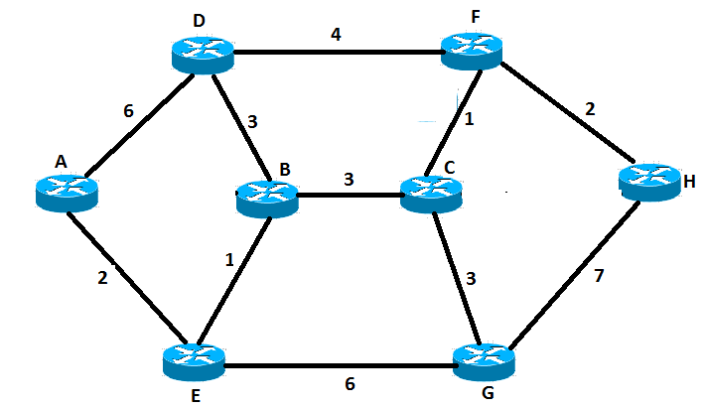

**[Total 30 Marks]**

**QUESTION 3**

‘Where a traditional WAN connects multiple LANs through routers and VPNs, SD-WANs combine WAN technologies like Multiprotocol Label Switching (MPLS) and broadband connections to deliver connections between multiple physical office settings (or an office to a WFH environment)’ *Andrew Lerner, Vice President Gartner Research.2020*

1. What is the full form of SD-WAN? [2 Marks]
2. Define SD-WAN. [4 Marks]
3. Provide two key components to an SD WAN Solution. [4 Marks]
4. Andrew Lerner mentioned VPNs in 2020 where COVID forced employees to Work From Home. Explain how VPN technology works with the help of a clearly labelled diagram.
5. Describe the VPN technology. [4 Marks]
6. With the help of a clearly labelled diagram, describe how a VPN works. [6 Marks]
7. A DHCP Server is a network server that automatically provides and assigns IP addresses, default gateways and other network parameters to client devices.
   1. IP assignment may be done via a DHCP server. What is a DHCP Server [2Marks]
   2. Describe the four steps of the DHCP server with the help of a diagram. [8 Marks]

**[Total 30 Marks]**

**QUESTION 4**

1.Computers need to be protected and made more secure. You are the newly appointed Network Administrator and you have been requested to access your companies network and talk abour the following

Describe the following computer security terms:

a) Anti-virus software; [2 Marks]

b) Anti-spyware; [2 Marks]

c) Access Control List; [2 Marks]

d) Pop up blocker. [2 Marks]

2 Explain the purpose of each of the following commands:

a) FTP; [4 Marks]

b) Pathping; [4 Marks]

c) Tracert; [4 Marks]

d) Netstat. [4 Marks]

3.Identify the following types of digital communication media, typical transmission speeds and the medium used to provide a communications link

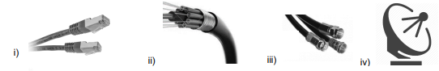

a) Rank the media above in terms of its fastest first to slowest. [2 Marks]

b) Explain which media would be best suited for use in high voltage and electromagnetic environments? Justify your answer. [4 Marks]

**[Total 30 Marks]**

**\*\*\*\*\*\*\*\*\*\*\*\*\*\*\*\*\*\*\*\*\*END OF QUESTION PAPER\*\*\*\*\*\*\*\*\*\*\*\*\*\*\*\*\*\*\*\*\*\*\***